# Conflict Scenario

## **Review**

### Interpersonal Conflict Management Styles

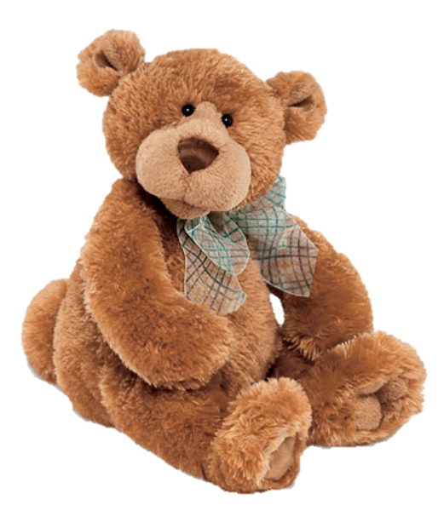

[CC 2.0 BY Matthew](https://www.flickr.com/photos/falcon1961/3304306800/)



[CC SA 3.0 Unported BY Jonathan Zander](https://en.wikipedia.org/wiki/File:Florida_Box_Turtle_Digon3.jpg)



[CC 3.0 BY Superawesomevectors](https://superawesomevectors.deviantart.com/art/Shark-Cartoon-Free-Vector-Illustration-643399222)



[CC0](https://pixabay.com/en/urban-lost-hiding-afraid-1002149/)

Low to High Concern for Other

Concern for Self



CC SA 2.0 Generic BY [Carine06 from UK](https://commons.wikimedia.org/wiki/File:Flickr_-_Carine06_-_%22I_give_up.%22.jpg)



CC 2.0 BY [Zabara Alexander](https://www.flickr.com/photos/zabara_tango/6955720271)



[CC0](https://commons.wikimedia.org/wiki/File:US_Army_53525_Soldiers_compete_in_Tae_Kwon_Do_tournament_for_Warrior_Country_level.jpg)

### **Interpersonal Conflict Resolution**

The following diagram shows a process that can be followed when trying to resolve interpersonal conflict.

### Listening

A considerable proportion of our communication involves listening, yet little attention is devoted to improving listening. HURIER is an acronym for tips that can be used to improve listening.

### “I” Phrases for Conflict Resolution

The “I” phrase is used during conflict resolutions to avoid attacking others. Open the conversation with a statement in first person, passive voice: “I feel … when … because … I would like …”

Adapted from (Dwyer 2012, p. 40)

## **Student Name and ID:** Jack Small

## **Student Name and ID:** Tamika R

## **Scenario**

Find a partner. Read the scenario below. Choose one partner to be Joe Bloggs, and the other to be Jane Doe. Together, answer the following to help prepare you for the role play.

## **Scenario: Joe did not complete a task by the deadline**

Joe and Jane are working on a report that is due today. Joe was assigned the task of writing the executive summary. Unfortunately, Joe has not completed the task.

What is the most appropriate conflict management strategy for Jane to use in this situation? (Choose one)

Compete/Force

Compromise

Avoid/Withdraw

Collaborate/Confront

Accommodate/Smooth

Why did you choose the above conflict management strategy?

As both Jane and Joe are working on the project, collaboration would be their best bet to solve the given conflict. Even though Joe was given the task of completing the executive summary, it is in both of their interests to complete the task and as such Jane can’t just avoid or accommodate for the issue and has to confront it in some way. Forcing Joe to do it would have a high likelihood of just putting him off the task even more, and a compromise just doesn’t seem possible/correct for the given scenario.

### **Listen and Understand**

How could Jane start the conversation?

She could ask Joe if he has made any progress on the summary. Since he hasn’t, and assuming Jane has completed her work, she could offer him some assistance on how to get started.

Describe the purpose of the discussion. Describe the conflict. What questions could Jane ask to determine Joe’s perspective of the situation?

The purpose of the discussion would be to determine why Joe hasn’t completed the executive summary that was due today. Jane could ask if he had some other task he was prioritising or if he had factors outside of work affecting his ability to get it done. She could ask if he was aware of the due date coming up.

Write sentences that features the “I” phrase, such as in the example below:

“I feel *[your feeling]* when *[their behaviour]* because *[effects on you]*. I would like *[alternative behaviour]*”.

“I feel stressed when you don’t complete your assigned work because it puts a lot more pressure on the both of us considering it is due so soon. I would like you to warn me if you won’t be able to complete the task on time or I would’ve liked you to have asked for help if you needed any.”

Invent a reason why Joe did not complete the executive summary by the deadline.

Joe had an important business trip with the assistant manager to attend a company meeting in a different town.

How could Jane paraphrase Joe’s reason for missing the deadline to ensure that she understands Joe’s perspective?

Joe was working on another important task that took priority over the summary.

### **Empathise**

Now that Jane understands Joe’s perspective, how could Jane empathise with Joe? Write a response that shows that Jane identifies with Joe’s emotions.

Jane has previously been on similar trips and understands how difficult it can be to complete other tasks while away from home/the workplace. Jane can empathise with the stress he would’ve been under due to having such an important business trip as well as other tasks due all at the same time.

### **Apologise**

Include an apology if it is appropriate.

“I’m sorry for not checking in on you earlier, I didn’t realise you were under so much stress.”

### **Offer Solution**

What question could Jane ask to help build Joe’s involvement with potential solutions?

“Have you made much progress on the summary, would you like me to help you get a start or come up with some points to add, or do you think you can handle it on your own?”

Come up with a way for Jane and Joe to settle on a solution.

Jane could help Joe start the executive summary and/or give him an outline/dot points on what he needs to include in the text.

### **Resolution**

How could Jane resolve the conflict? Jane needs to ensure that Joe agrees. Write a response that outlines appreciation for the solution.

Jane – “I could help you get started with writing the summary or give you some points on what needs to be included if you’re ok with that?”

Joe – “Yes thanks, I would appreciate it, I’ve got some ideas already but it’d be a huge help if you could get me started on how to write it.”

### **Reconciliation**

How could Joe reconcile the relationship and let Jane know that she is important to him?

“Thank you for being able to understand that I was on the business trip and was struggling to complete the work. I really appreciate you being so considerate and offering to help me out even if you didn’t have to. I do appreciate our friendship, if you wanted I could shout you something to eat over the weekend or a movie or something. 😊”

How can Jane let Joe know she is listening while Joe is talking?

Jane can give non-verbal feedback by giving Joe eye contact while he is talking, avoiding being on any phones or technology and giving slight head nods to show interest. She should also give verbal feedback in the form of ‘yeps, uh-huhs, etc.’.

What could Jane do if Joe started to withdraw from the conflict at any stage?

She should just reaffirm to him that she is there to help and isn’t trying to attack him in any way. They are both tasked to the report so they should try their best to work together to get it done. If Joe is refusing to cooperate or doesn’t want to agree to the original solution, Jane could try to come up with a smaller compromise that will keep them both happy.